24SDCS02 / 24SDCS02E / 24SDCS02P / 24SDCS02L – FSAD WORKBOOK

DEPARTMENT OF CSE, CS&IT, AI&DS
COURSE CODE: 24SDCS02 / 24SDCS02E / 24SDCS02P / 24SDCS02L
FULL STACK APPLICATION DEVELOPMENT
Date of the Session: / / Time of The Session: to
#SKILL - 6 ⎝ Spring MVC Web Request Handling Demo
Prerequisites:
• General Idea on Spring Web MVC and Form Handling
• Basic understanding of Spring Boot
• Understanding of HTTP methods (GET/POST)
An online library system wants to allow users to explore books, view specific book details, submit feedback, and interact with the system through various types of requests. To support these features, the backend team needs to implement multiple Spring MVC endpoints demonstrating request mappings, path variables, request parameters, and JSON data handling. Your task is to create a Spring Boot MVC controller that exposes different demo operations using @RestController, @GetMapping, @PostMapping, and @PathVariable.
Tasks:
1. Create a controller class named LibraryController.
2. Create a method mapped to /welcome that returns a welcome message.
3. Create a method mapped to /count that returns an integer representing total books.
4. Create a method mapped to /price that returns a sample book price as double.
5. Create a method mapped to /books using @GetMapping that returns a list of book titles.
6. Create a method mapped to /books/{id} using @GetMapping and return book details using @PathVariable.
7. Create a method mapped to /search using @GetMapping that accepts a request parameter (title) and returns a confirmation message.
8. Create a method mapped to /author/{name} using @GetMapping that returns a formatted message with the author’s name.
9. Create a method mapped to /addbook using @PostMapping that accepts a Book object from the request body and adds it to an in-memory list.
10. Create a method mapped to /viewbooks using @GetMapping that returns all added Book objects.
11. Push the Spring Boot project to GitHub.
STRUCTURE:
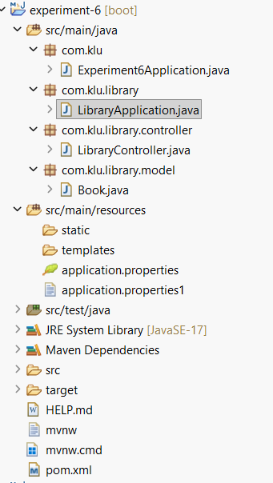

LibraryApplication.java
package com.klu.library;
import org.springframework.boot.SpringApplication;
import org.springframework.boot.autoconfigure.SpringBootApplication;

@SpringBootApplication
public class LibraryApplication {

public static void main(String[] args) {
SpringApplication.run(LibraryApplication.class, args);
}
}

LibraryController.java
package com.klu.library.controller;

import com.klu.library.model.Book;
import org.springframework.web.bind.annotation.*;

import java.util.ArrayList;
import java.util.Arrays;
import java.util.List;

@RestController
public class LibraryController {

List<Book> books = new ArrayList<>();

@GetMapping("/welcome")
public String welcome() {
return "Welcome to Online Library System";
}

@GetMapping("/count")
public int countBooks() {
return 100;
}

@GetMapping("/price")
public double getPrice() {
return 499.99;
}

@GetMapping("/books")
public List<String> getBooks() {
return Arrays.asList(
"Java Programming",
"Spring Boot Guide",
"Microservices Architecture",
"Data Structures"
);
}

@GetMapping("/books/{id}")
public String getBookById(@PathVariable int id) {
return "Details for Book ID: " + id;
}

@GetMapping("/search")
public String searchBook(@RequestParam String title) {
return "Searching for book: " + title;
}

@GetMapping("/author/{name}")
public String getAuthor(@PathVariable String name) {
return "Books written by " + name;
}

// 8 Add book using POST
@PostMapping("/addbook")
public String addBook(@RequestBody Book book) {
books.add(book);
return "Book added successfully";
}

// 9 View all books
@GetMapping("/viewbooks")
public List<Book> viewBooks() {
return books;
}
@GetMapping("/")
public String home() {
return "Library API is running";
}
}

Book.java
package com.klu.library.model;

public class Book {

private int id;
private String title;
private String author;
private double price;

public Book() {
}

public Book(int id, String title, String author, double price) {
this.id = id;
this.title = title;
this.author = author;
this.price = price;
}

public int getId() {
return id;
}

public void setId(int id) {
this.id = id;
}

public String getTitle() {
return title;
}

public void setTitle(String title) {
this.title = title;
}

public String getAuthor() {
return author;
}

public void setAuthor(String author) {
this.author = author;
}

public double getPrice() {
return price;
}

public void setPrice(double price) {
this.price = price;
}
}

Application.properties
spring.application.name=experiment-6
server.port=8082

OUTPUTS:
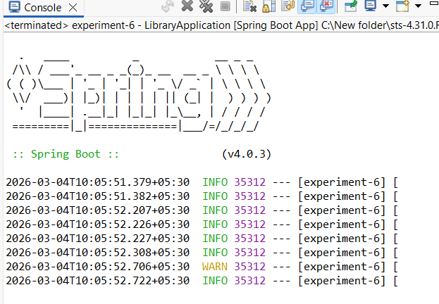
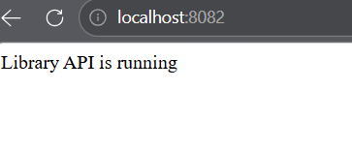
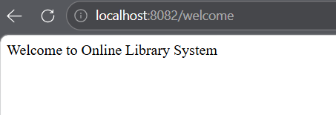

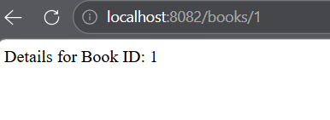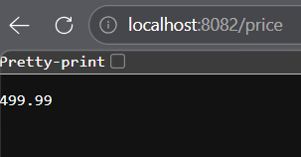
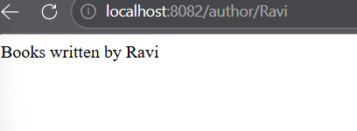
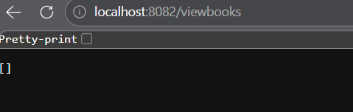
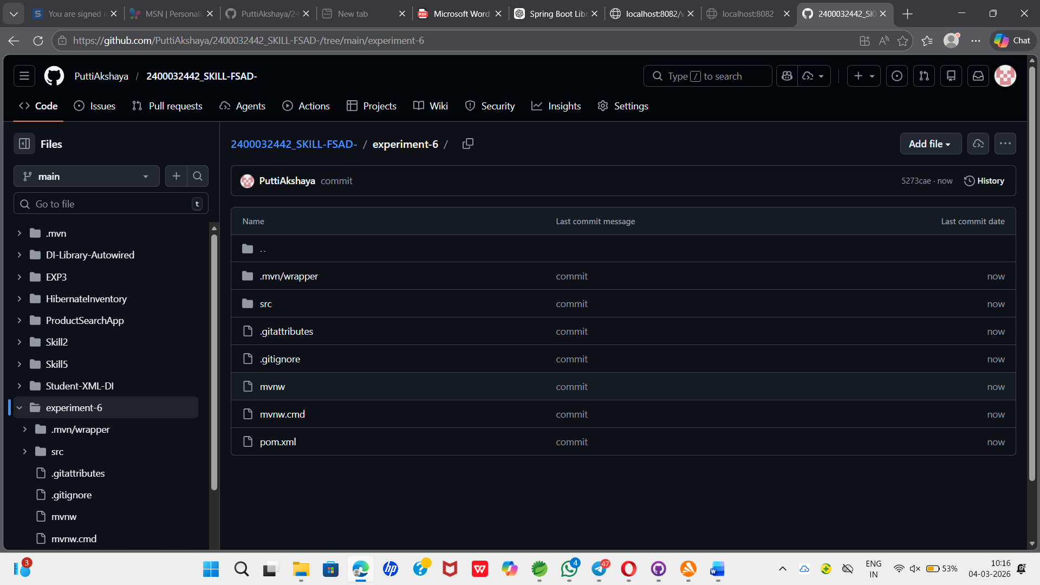
VIVA QUESTIONS:
- What is the role of @RestController in Spring MVC?
A. @RestController is used to create RESTful web services. It combines @Controller and @ResponseBody, so methods return data (JSON/text) directly instead of a view.
2. What is the difference between @GetMapping and @PostMapping?
A. @GetMapping → used to retrieve data from the server.
@PostMapping → used to send or create data on the server.
3.How does @PathVariable help in handling dynamic URLs?
A.@PathVariable extracts values from the URL path and passes them to a method parameter.
Example:
/books/{id} → gets the book ID from the URL.

4. When do we use @RequestParam?
A. @RequestParam is used to get query parameters from the URL.
Example:
/search?title=Java

5. Can one controller contain multiple request-mapped methods?
A. Yes. A single controller can have multiple methods mapped to different URLs and HTTP requests.

(For Evaluator’s use only)
Comment of the Evaluator (if Any) Evaluator’s Observation
Marks Secured: out of
EMP ID & Full Name of the Evaluator: Signature of the Evaluator Date of Evaluation:

